**C Programming and Data Structures**

**Computer Science and Technology-B**

**Week 9**

**9. Implement the following searching techniques**

**a) Linear Search b) Binary Search**

**a)Linear Search**

**Program:**

#include<stdio.h>

void main()

{

int a[10],s,i,n;

printf("Enter number of elements:");

scanf("%d",&s);

for(i=0;i<s;i++)

{

printf("Enter element %d:",i+1);

scanf("%d",&a[i]);

}

printf("Enter the element to search:");

scanf("%d",&n);

for (i=0;i<s;i++)

{

if (a[i]==n)

{

printf("Element found at index %d",i);

break;

}

else if(i==(s-1)&&a[i]!=n)

{

printf("Not found");

}

}

}

**Output:**

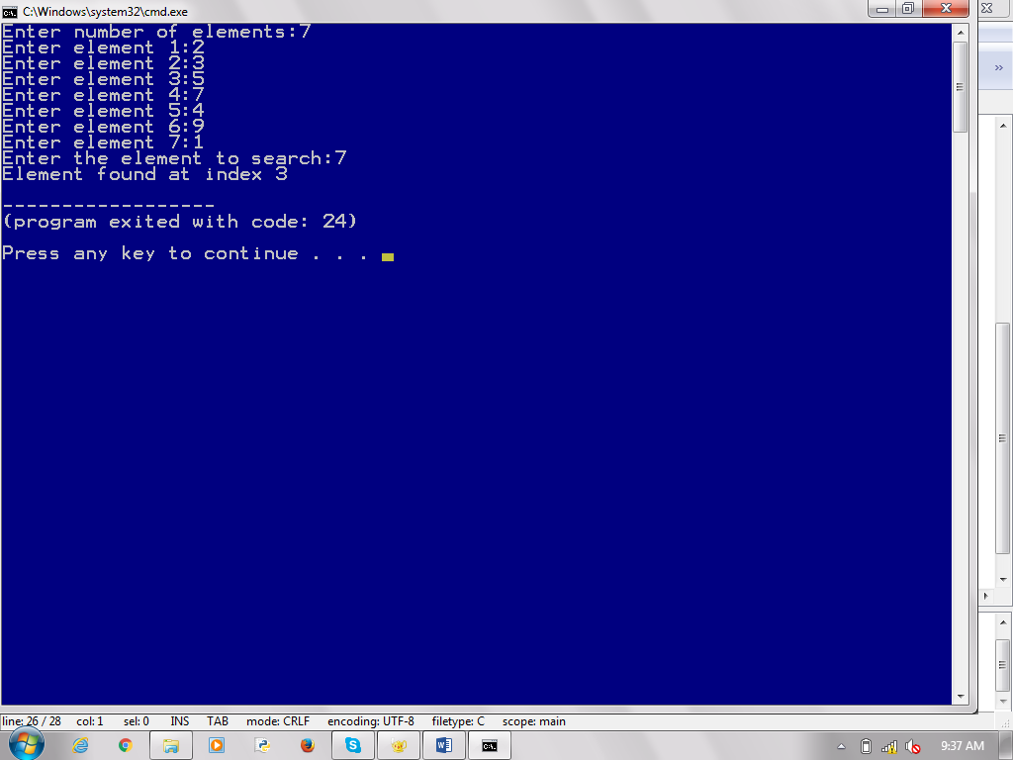

**b)Binary Search**

**Program:**

#include<stdio.h>

void main()

{

int low,high,mid,n,s,i,a[100];

printf("Enter number of elements:");

scanf("%d",&s);

for(i=0;i<s;i++)

{

printf("Enter element %d:",i+1);

scanf("%d",&a[i]);

}

low=0;

high=(s-1);

mid=(low+high)/2;

printf("enter the element to search:");

scanf("%d",&n);

while(low<=high)

{

if(a[mid]==n)

{

printf("%d found at index %d",n,mid);

break;

}

else if(a[mid]<n)

{

low=mid+1;

}

else if (a[mid]>n)

{

high=mid-1;

}

mid=(low+high)/2;

}

if(low>high)

{

printf("Element not found");

}

}

**Output:**

